Data science project

“Impact of Social Media on Teen Mental Health
Name: Amna Khan
Course: Data Science
Date: 02-MAY-2026

Overview

Project background and description
This project analyzes the relationship between social media usage and depression levels among teenagers using data science techniques. The dataset includes variables such as daily social media usage, academic performance, and depression labels. The data was cleaned, processed, and analyzed using Python in Google Collab. A Logistic Regression model was applied to predict depression levels based on social media usage. Visualizations such as histograms and scatter plots were used to understand patterns. The results indicate a noticeable relationship between increased social media usage and higher chances of depression.
The dataset used in this project is titled:
“Teen Mental Health Dataset”
Key Features:
* The "Teen Mental Health Dataset" (1200 rows, 13 columns) includes:
* daily_social_media_hours → Time spent on social media
* academic performance → Student academic score
* depression label → Target variable (0 = No Depression, 1 = Depression)
The dataset was uploaded into Google Collab using file upload functionality.
TOOLS AND TECHNOLOGIES:
* Python
* Google Collab
* Libraries
* Pandas
* NumPy
* Matplotlib
* Scikit-learn

methadology
Data collection: The dataset was uploaded manually using google colab file upload feature.
uploaded = files.upload()
df = pd.read_csv('Teen_Mental_Health_Dataset (1).csv')

Data Exploration
- Initial exploration was done using:
df.head()
df.info()
df.describe()
- This helped in understanding structure, data types, and summary statistics

Data Cleaning
The dataset was cleaned using the following steps:

* Removed missing values
* Removed duplicate records
* Standardized column names
df = df.dropna()
df = df.drop_duplicates()
df.columns = df.columns.str.strip().str.lower().str.replace(' ', '_')

Exploratory Data Analysis (EDA)
Histogram:
plt.hist(df['academic performance'])
This shows distribution of academic performance.
plt.scatter(x, y)
This shows relationship between social media usage and depression
X_train, X_test, y_train, y_test = train_test_split(x, y, test_size=0.2, random_state=42)
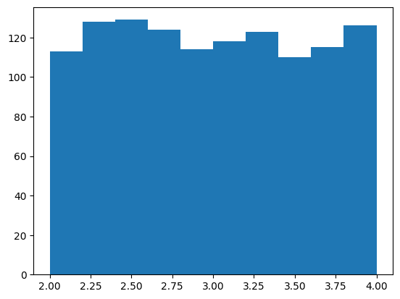
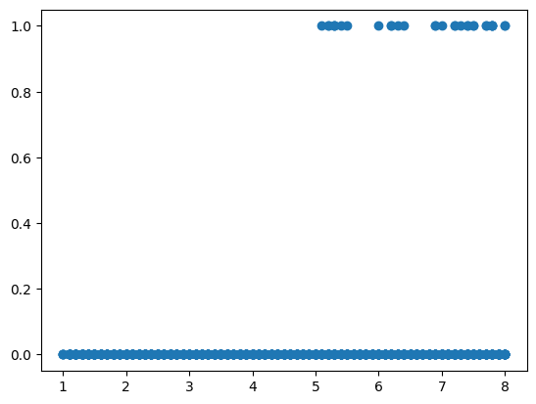
Dataset was divided into:
* 80% training
* 20% testing

Model Building (Logistic Regression)
model = LogisticRegression()
model.fit(X_train, y_train)
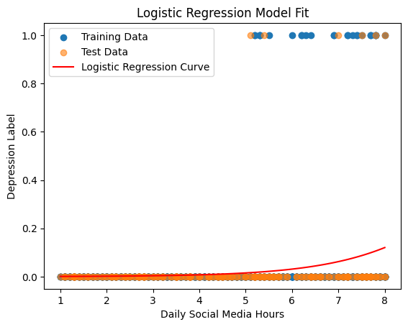
Logistic Regression was used because the target variable (depression label) is categorical

Model Visualization
A curve was plotted to show model predictions
plt.plot(X_plot, y_prob_plot, color='red')
This represents probability of depression based on social media usage.

Model Evaluation
accuracy_score(y_test, y_pred)
Accuracy was calculated to evaluate model performance

📊 RESULTS AND FINDINGS
* Increased social media usage is associated with higher depression probability
* Scatter plots show a positive relationship between screen time and depression
* Logistic Regression curve indicates rising probability trend
* Academic performance distribution varies across students

📈 VISUALIZATIONS
(Insert your screenshots here)
* Histogram of academic performance
* Scatter plot (social media vs depression)
* Logistic regression curve

DISCUSSION
The analysis shows that social media usage plays a role in influencing mental health. As usage increases, the likelihood of depression also increases. However, other factors such as academic performance and lifestyle may also contribute.

LIMITATIONS
* Limited dataset features
* Only one main predictor used
* Possible data imbalance
* External factors not included
performance and lifestyle may also contribute.

CONCLUSION
This project concludes that there is a measurable relationship between social media usage and depression among teenagers. Logistic Regression successfully modeled this relationship and provided insights into mental health trends.

FUTURE WORK
* Include more features (sleep disorder, anxiety, lifestyle)
* Use advanced models (Decision Tree, Random Forest)
* Improve dataset size and quality

📚 REFERENCES
* Scikit-learn Documentation
* Python Libraries
* Google Collab

